


SAVEETHA SCHOOL OF ENGINEERING

SAVEETHA INSTITUTE OF MEDICAL AND TECHNICAL SCIENCES

COMPUTER SCIENCE AND ENGINEERING PROGRAMME

LAB MANUAL CSA1305

THEORY OF COMPUTATION

COMPUTER SCIENCE AND ENGINEERING PROGRAMME

LIST OF EXPERIMENTS

8. Write a C program to check whether a given string belongs to the language defined by a Context Free Grammar (CFG) S → A101A, A → 0A | 1A | ε

AIM:
To write a C program to check whether a given string belongs to the Context Free Grammar (CFG):
S → A101A
A → 0A | 1A | ε

Apparatus Required
- Computer/Laptop
- GCC Compiler (Turbo C/GCC/CodeBlocks/VS Code)
- C Programming Language

Algorithm
- Start the program.
- · Read the input string.
- · Find the length of the string.
- · Search for the substring "101" in the input string.
- · If the substring "101" is present, the string belongs to the grammar because A can generate any binary string (including ε).
- · Otherwise, the string does not belong to the grammar.
- · Display the result.
- · Stop the program.

Program Code

#include <stdio.h>

#include <string.h>

int main()

{

char str[100];

int i, len, flag = 0;

printf("Enter the binary string: ");

scanf("%s", str);

len = strlen(str);

for(i = 0; i <= len - 3; i++)

{

if(str[i] == '1' && str[i+1] == '0' && str[i+2] == '1')

{

flag = 1;

break;

}

}

if(flag)

printf("The string belongs to the grammar.\n");

else

printf("The string does not belong to the grammar.\n");

return 0;

}

Sample Input 1
Enter the binary string: 1101010

Sample Output 1
The string belongs to the grammar.

OUTPUT: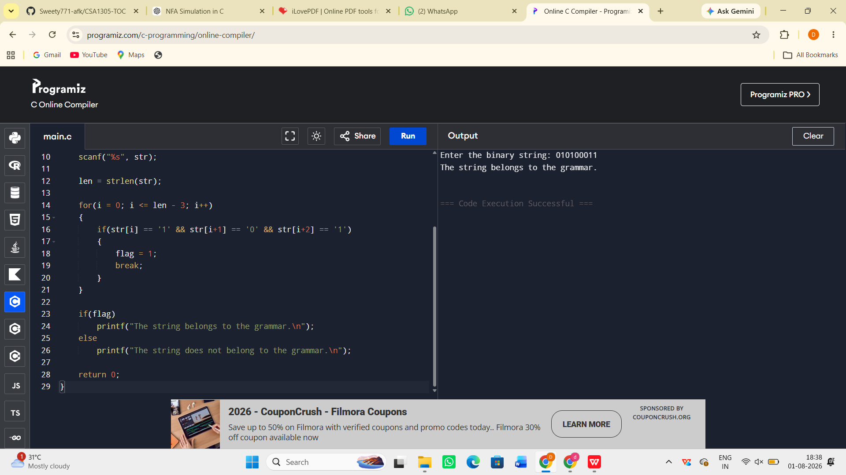

Result:
The C program to check whether a given string belongs to the Context Free Grammar S → A101A, A → 0A | 1A | ε was successfully implemented and executed. The program correctly accepts binary strings containing the substring "101" and rejects all other strings.

